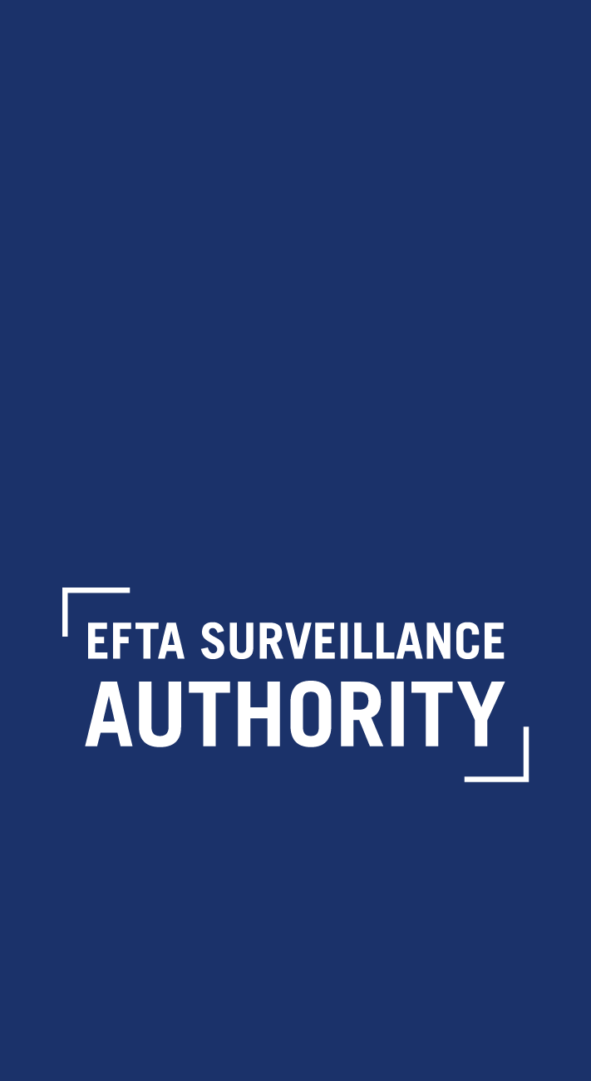

Annex B: Standard Non-Disclosure Agreement

NON-DISCLOSURE AGREEMENT

Case No [XX] – [CASE NAME]

Whereas I, the undersigned,

Declare that I have been engaged as an external advisor by [Name(s) of Party/Parties to which data room access is granted through their External Advisors] (the “[Party/Parties]”) in connection with Case No [XX] – [CASE NAME] and I am duly authorised by the same to make the below undertakings;

Whereas the EFTA Surveillance Authority (the “Authority”) has, for the sole purpose of enabling the external [economic advisor/legal consultant] of the [Party/Parties] to verify the validity of its data analysis, made available a data room containing data collected from [Name(s) of Data Provider(s)] (the “Data [Provider/Providers]”) during the course of its investigation that have been used by the Authority in the analysis presented in the Statement of Objections (the “Data”, as specified in Annex 1 of the Terms of Disclosure of Business Secrets and other Confidential Information on an “External Advisor Only” basis (the “Data Room Rules”));

Whereas, for the purpose of verifying the validity of the Authority’s data analysis in the Statement of Objections, the [Party has/Parties have] released me from the professional duties and obligations I have towards the Parties, as their appointed external [economic advisor/legal consultant] in the above referenced proceeding, to disclose all relevant Data to the [Party /Parties] as my client[s];

Whereas the Data constitute business secrets and other confidential information and must not be disclosed under any circumstances to the [Party/Parties] or to any other third party;

Therefore, I solemnly undertake:

- to use the Data solely for the preparation of a data room report (the “Data Room Report”) addressed to the [Party/Parties], and if necessary of a non-redacted, confidential version of the Data Room Report addressed to the Authority (according to Section 3 of the Data Room Rules) containing my findings and conclusions on [the validity and soundness of the Authority’s quantitative analyses adopted in the Statement of Objections / whether the qualitative evidence on the Authority’s file supports the objections raised by it];
- not to copy (in any format, physical, digital or otherwise) or remove any Data from the data room, and to fully abide by the procedures set forth in the attached Data Room Rules;
- not to disclose, transmit, communicate or make the Data provided by the Data Provider[s] or contained in the Data Room Report (or any observations, comments, inferences or conclusions drawn from such Data or such Data Room Report) available in any manner, shape or form to any other person (including the [Party/Parties]) other than as provided in paragraph (v) below;
- to ensure that the Data Room Report does not contain any business secrets and other confidential information supplied by the Data Providers, and does not in any way reveal any such business secrets and other confidential information, whether directly, indirectly or by implication;
- to provide the Data Room Report to the Authority, prior to its communication to the [Party/Parties], in order for the Authority to verify that no business secrets and other confidential information have been copied or otherwise revealed;
- to duly and promptly inform the Authority of any breaches of these undertakings, whether as a result of my actions or failings or the actions of others, as soon as I become aware of them; and
- to procure the full compliance with the terms of this agreement by any and all persons who work with me in any capacity in reviewing and analysing the Data in the data room and/or preparing the Data Room Report, and to provide a list of all such persons to the Authority and their signed acceptance of the terms of this agreement.

……………………….
Name:
Function:
Date:
Place:

