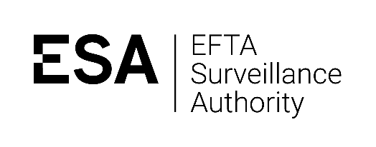

2019 EEA Law Moot Court Participation Form

This form should be handed in with your written submissions.

Please provide the below details for all participants in your team:

Name | Email Address | Year of Study  (e.g. 3rd year undergraduate, 1st year masters) | University | Consent for use of photos  (yes/no)  (*see below)

Data Protection
By this form, we are collecting your personal data in line with our Rules on Data Protection and in particular with Notification No 80285 in order to run the moot court competition, and to ask for feedback after the competition has ended. We like to stay in touch with mooters, so we may also use this information to contact you to ask what you get up to in your career after the moot.

* The final column in the table above is to ask whether you would be happy with our photographer taking pictures of you during the moot and using them to promote the competition.

If you have any questions on how ESA handles data collected in this form, please see our Privacy Statement or contact our Data Protection Officer at: dpo@eftasurv.int

